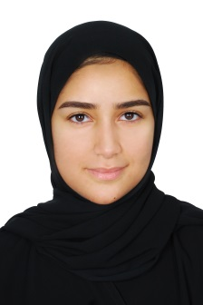**Zainab A.jalil | Finance student**

**Location: hamad town**

**E-mail:zainabyialaradi@gmail.com**

**+973 33119188**

**Objective**

Looking forward to work at organization that offers continued promising career growth of skills under challenging work environment.

**Education**

2017 graduated from secondary school , commercial

2017 until 2019 university of Bahrain student – banking and finance major

**Summery**

I have knowledge of MICRASOFT especially EXCEL program , accountant experience

Good in the English language

Excellent knowledge in social media

Good communication skills

**Work Experience**

Worked at secretary office in Alsalmania hospital (community service activity) Juley and august 2014